Create Node-RED Service

|  |  |
| --- | --- |
| Date | 18 November 2022 |
| Team ID | PNT2022TMID49268 |
| Project Name | Project – Smart Farmer-IoT Enabled smart Farming Application |

Steps for creating Node-RED Service

1. Find the Node-RED Starter Kit in the IBM Cloud catalog.
2. Create your application.
3. Enable the Continuous Delivery feature.
4. Open the Node-RED application.
5. Configure your Node-RED application.
6. Add extra nodes to your Node-RED palette

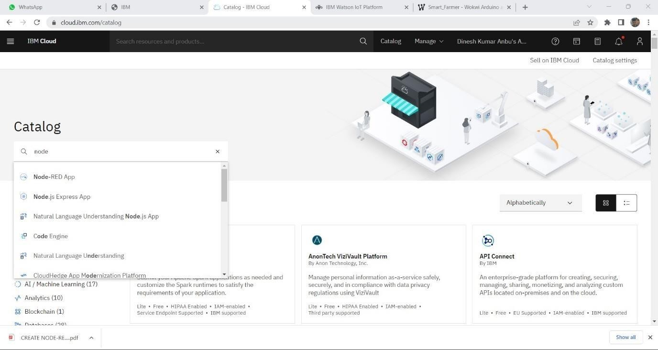

STEP 1: Find the Node-RED Starter Kit In The IBM Cloud Catalog

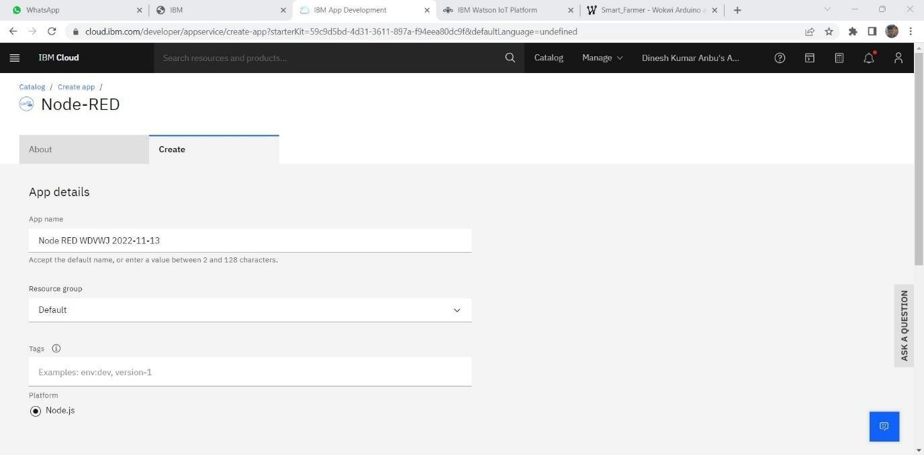

STEP 2: Create Your Application

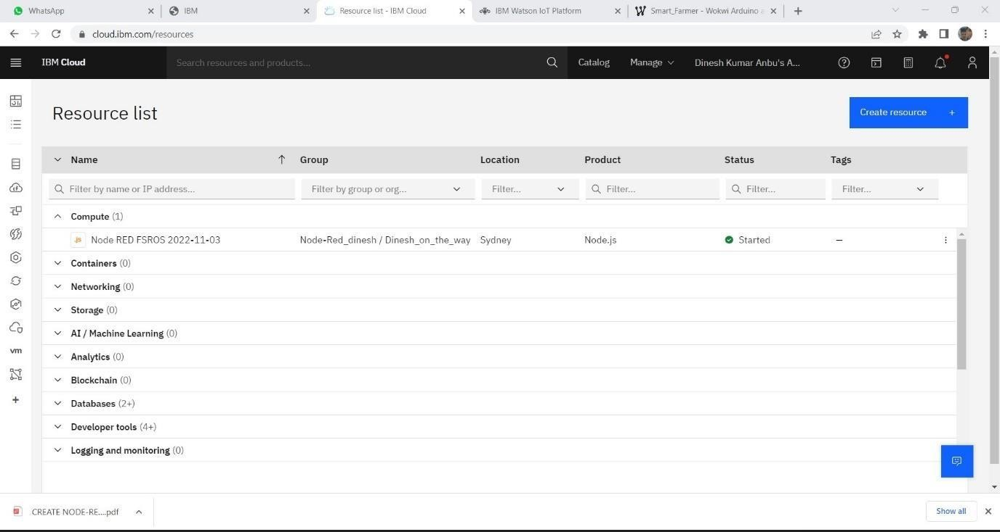

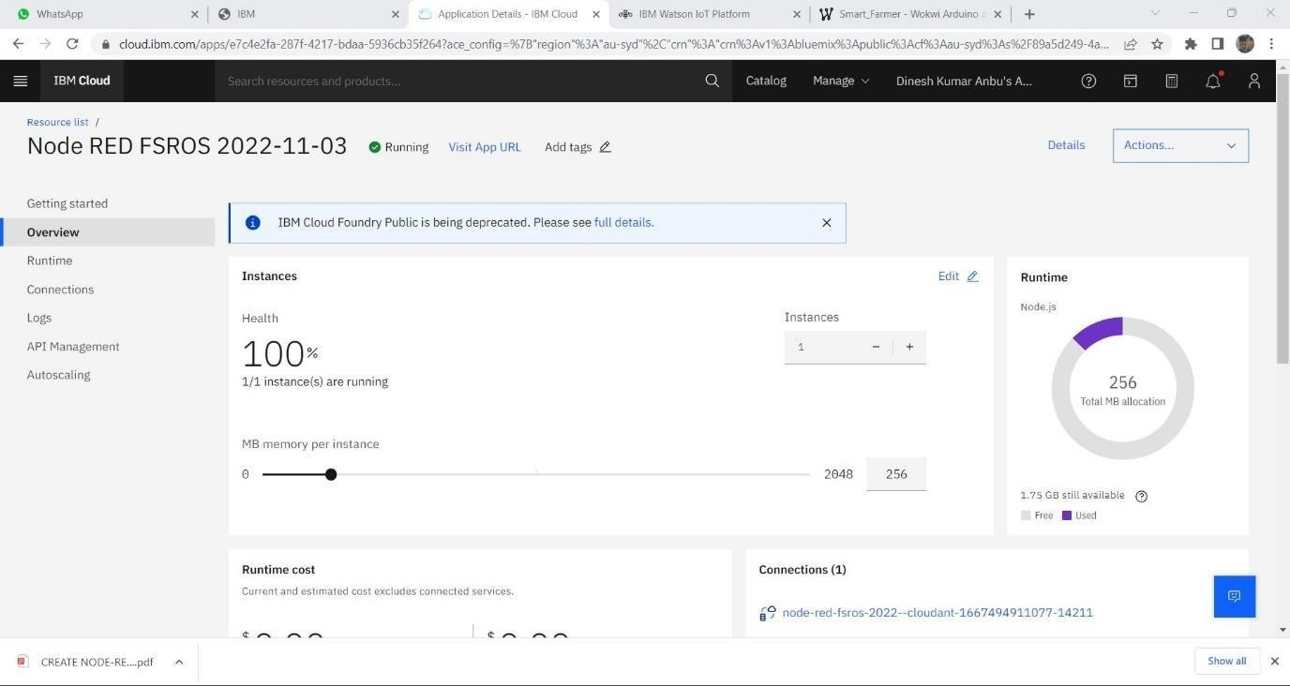

STEP 4: Open the Node-RED application

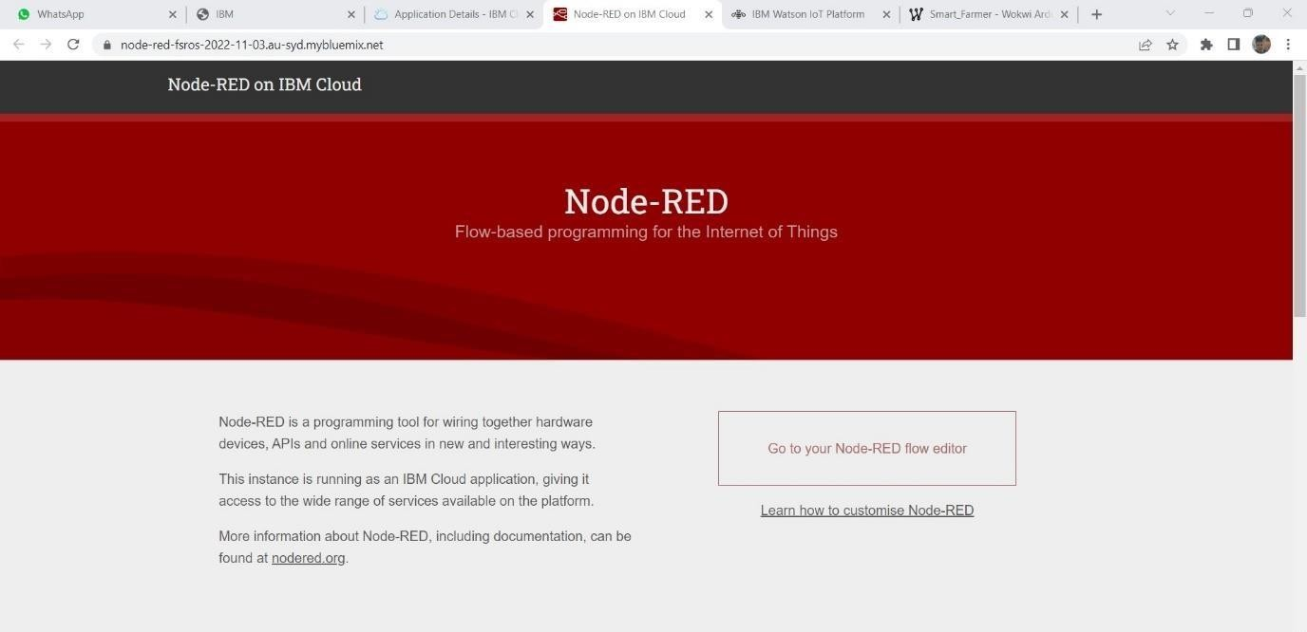

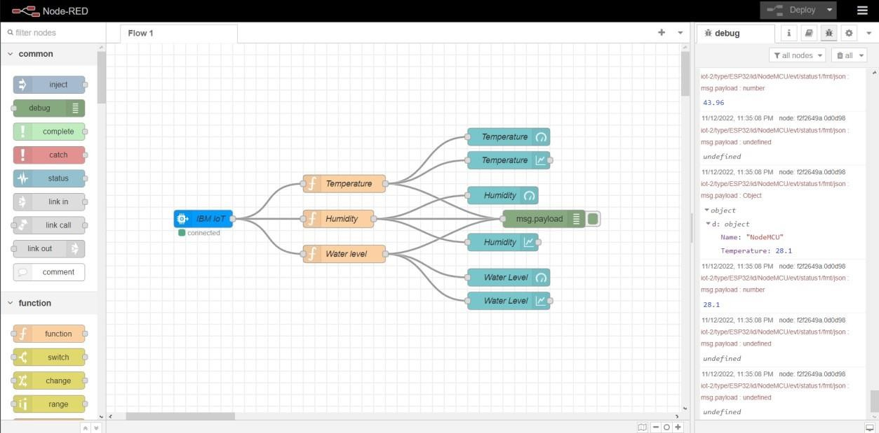

SEP 6: Configure your Node-RED application

